Group 1 members:
Koo Yu Min (A25CS5013)
Chloe Khoo (A25CS5012)
Chan Qing Jia (A25CS5019)
Lau Yu Xuan (A25CS5015)
Technology and Information Systems (SECP 1513)
Semester I 2025/2026

Project Design Thinking Report
- Introduction

1.1 What is Design Thinking?
Design thinking is a human-centered approach to problem-solving and innovation, focusing on understanding the people you are designing for. It consists of five phases: empathize, define, ideate, prototype and test.

1.2 Introduction to bus tracking problems
The Problem: Bus Tracking Issues
Bus tracking systems are meant to reduce "commuter anxiety" by providing real-time data. However, many current systems fail because of inaccurate GPS data, poor user interface (UI), or lack of communication when delays occur. This leads to passengers missing buses or waiting unnecessarily long at stops.

1.3 How Design Thinking Solves the Bus Tracking Problem
Design Thinking moves the focus from "how do we build an app" to "how do we make the passenger's journey seamless." For example:
Table 1: Idea of design thinking and explanation
Idea | Explain
Empathize & Define | Instead of guessing, we might discover that the real problem isn't just knowing where the bus is, but knowing if there is enough space on the bus or if it's stalled in traffic from the bus tracking app.
Ideate (Think Outside the Box) | 1. Smart bus stops with e-ink displays for those without smartphones.  2. A "crowdedness indicator" using weight sensors on the bus.  3. Push notifications that suggest alternative routes at the moment a delay is detected.
Prototype & Test | Create a "low fidelity" version, maybe a paper sketch or a simple digital mockup and put it in the hands of commuters at a bus stop.  Feedback: The map is too cluttering; I just want to see a countdown timer.  Adjustment: Simplify the interface based on real human behavior.

2.0 Design Thinking Process

2.1 Empathy Phase
We had focused on understanding the daily experiences, frustrations, and motivations of students using the campus bus system. By collecting data from 30 respondents and our interviewee through google form, we gain a deep sense of user empathy.

2.1.1 List of question and answer
Table 2: Question and possible answers for users.
No. | Question | Answer
1 | How often do you use campus buses? | Everyday
2 | How long do you wait for the bus? | Around 10 to 30 minutes
3 | What is your biggest frustration with the current bus system? | The bus did not follow the schedule, so I do not know where the bus was.
4 | How does a bus delay affect you? | High anxiety and missing lectures
5 | Would a real-time tracking map be helpful for your daily planning? | Yes, I could manage my time better
6 | Would you use “SOS” features if you felt unsafe at a bus stop? | Yes, I would feel safe.

2.1.2 Composite character
Name: Zhi Kwan
Age: 20
Background: Year 1 student from Faculty of Computing
Situations: Relies on campus bus for commuting between hostel and faculty, experiences “time anxiety” frequently because of an unpredictable bus schedule.
Goals: Track bus movement to avoid being late for exams or classes.

2.1.3 Data Analysis
Usage Frequency: 100% of our respondents rely on the campus bus as their primary transportation.
Wait Time: Approximately 80% of users spend 10 to 30 minutes waiting at the bus stop.
Core Pain Point: 68% of respondents think that the bus is not following schedule.
Emotional Impact: 100% of users feel “mad”, “helpless” and “stress” when bus delays with no notification.
Safety: Almost half of respondents felt unsafe when waiting alone or at night.
Solution: Majority of users think that Real Time GPS Tracking Map, Emergency SOS Button and notification of Bus Arriving Soon is a needed.

Figure 2-9: Survey results from 31 respondents
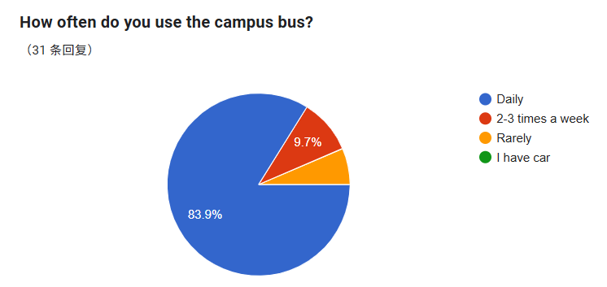
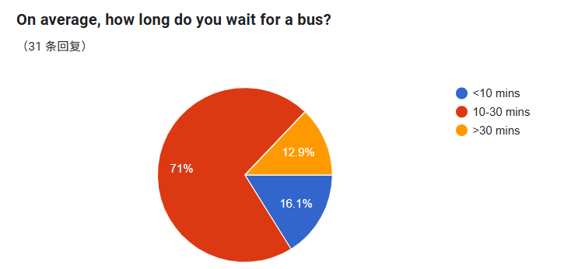
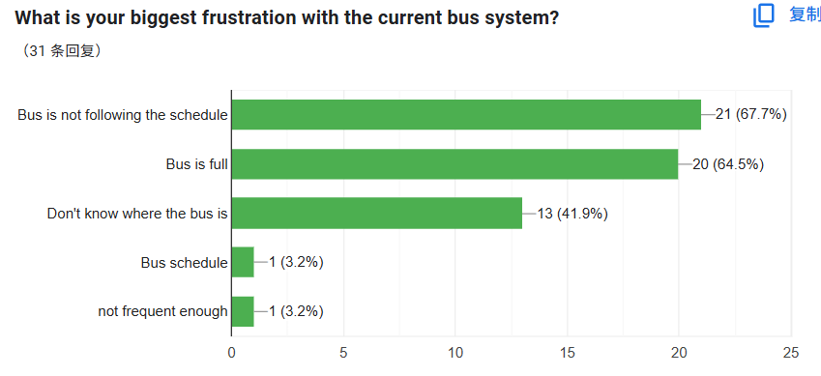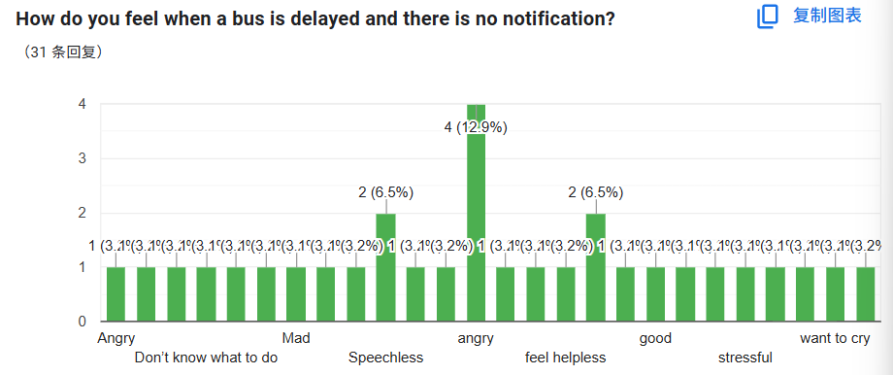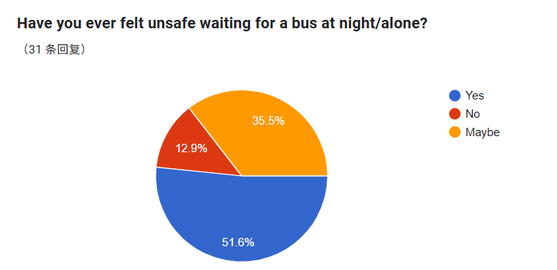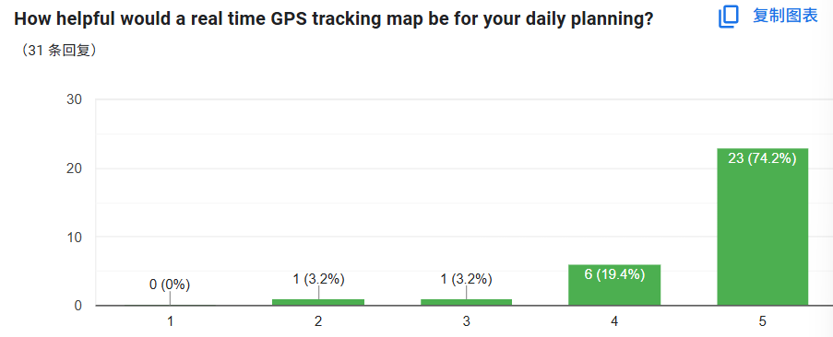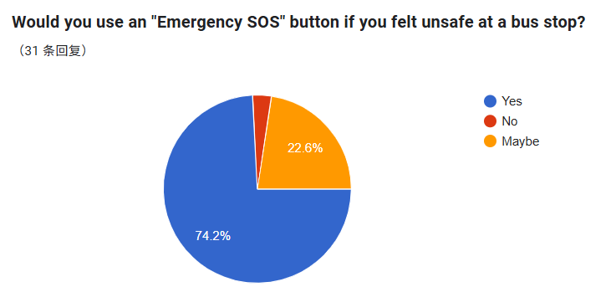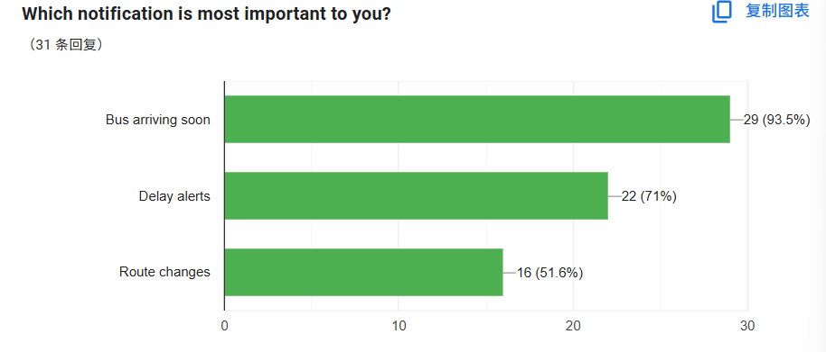

2.1.4 Insights
Data shows that the problem is not just about “transportation”, but about information transparency.
Transportation: We found that the bus system is not just a utility, but a major factor in student’s mental health. The lack of notification will lead to anxiety and madness, which will disrupt their day.
Transparency: The core pain point is the “unknown” to the system. Students can decide to wait or reschedule if they know exactly how long they need to wait.
Fundamental need: For students commuting alone or at night, a bus stop is a place of vulnerability. They need a SOS button as their safety assurance.
2.2 Define Phase

2.2.1 Problem statement
After analyzing the data from the empathy phase, we found that the core issue is not just “late buses,” but also lack of information that leads to anxiety and poor time management for students.

2.2.2 Users' needs
From the google form respondents and student interview (Zhi Kwan, who is often waiting bus for a long time and end up booking a grab), we identified the user's needs:

Track: Students need to track the real-time GPS location of the bus to avoid waiting for a bus that is already passed by the bus stop.

Evaluate: Students need to evaluate the estimated time of arrival (ETA) to manage their time schedule better.

Receive: Students need to receive instant notifications such as delays or schedule changes so that they can find alternative transportation if needed.

Secure: Students need to ensure their safety during night-time through sharing location and emergency features.

2.2.3 Reframed Challenge
Students need a way to track bus locations in real-time and receive instant safety alerts so they can manage their schedules efficiently and feel secure while commuting on campus.

2.3 Ideate Phase

2.3.1 Objective
Discuss how to select the best features for our bus tracking app prototype.

2.3.2 Brainstorming and Evaluation
Our team brainstormed features and evaluated them by scoring each on User Impact and Feasibility (1=Low, 5=High) in our own opinion. The results are shown in Table 1.
Table 3: Team Feature Idea Scoring Table
Feature Idea | Chan | Chloe | Lau | Koo | Avg.  Impact | Avg.  Feasibility | Decision
Real-time GPS Tracking | 5,5 | 5,4 | 5,5 | 5,3 | 5.0 | 4.25 | Core
ETA Display | 5,5 | 4,5 | 5,5 | 5,5 | 4.75 | 5.0 | Core
Delay Notification | 4,5 | 5,5 | 5,4 | 5,5 | 4.75 | 4.75 | Core
Auto Arrival Reminder | 3,4 | 4,4 | 4,3 | 4,4 | 3.75 | 3.75 | Phase 2
Night-time SOS & location sharing | 5,5 | 4,5 | 5,5 | 5,4 | 4.75 | 4.75 | Phase 2
AI Chat Assitant | 5,4 | 5,5 | 5,4 | 4,3 | 4.75 | 4.0 | Core
Search for bus | 5,5 | 5,4 | 4,4 | 3,4 | 4.25 | 4.0 | Phase 2
Scoring Format | (Impact, Feasibility） |  |  |  | (Average of Impact) | (Average of Feasibility) | (Decision based on scores)

2.3.3 Final Decision
Based on the result, we decided to develop the app in two phases. We will be more focus on four highest score features, then other features will be auxiliary features.
2.4 Prototype Phase

2.4.1 Tools
We used two methods to develop our app:
Hand-drawn User Flow Diagram: Planning overall steps when user open our app.
Canva: Create a prototype wireframe

2.4.2 Step 1: Mapping the Flow
Before designing any screen, we mapped out the complete user journey on paper clearly.

Figure 10: Hand-drawn user flow diagram.
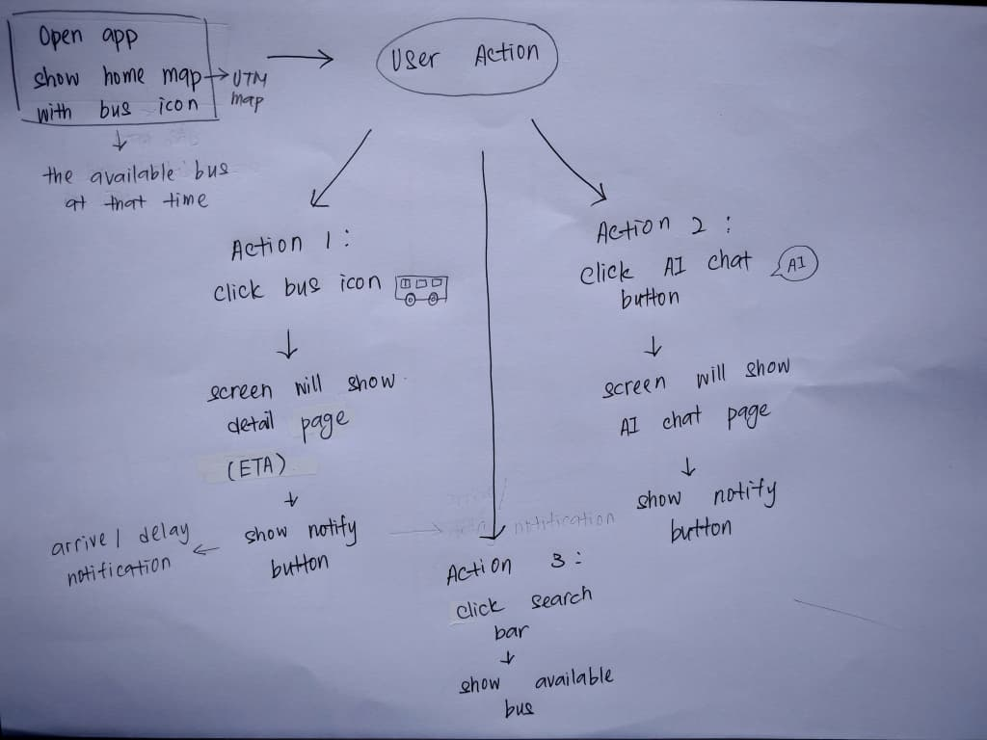

Step 2: Building the Screens
Following the flow in Figure 1, we used Canva to create each key step into a wireframe screen. We focused solely on layout and key elements using basic shapes.

Figure 11-16: Digital wireframe screens developed in Canva.

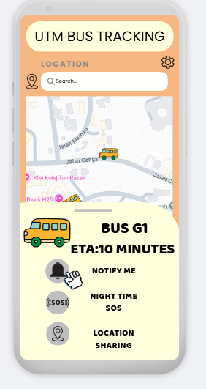
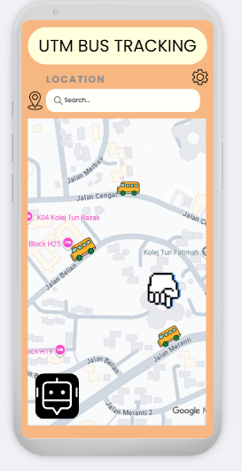

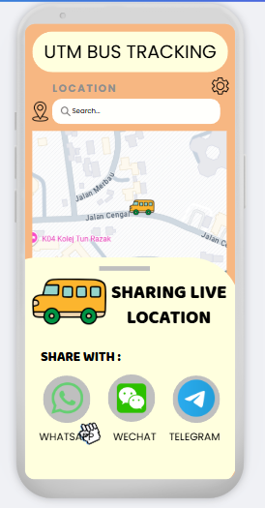
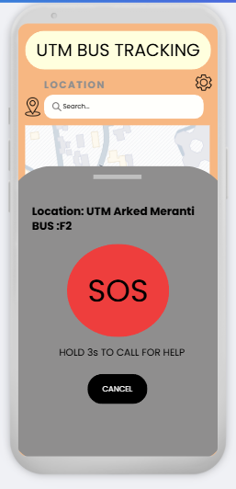

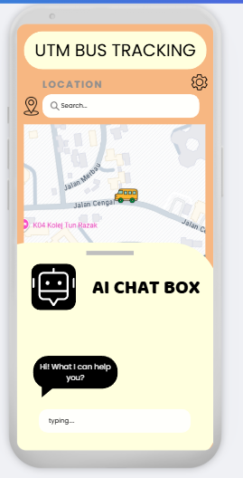
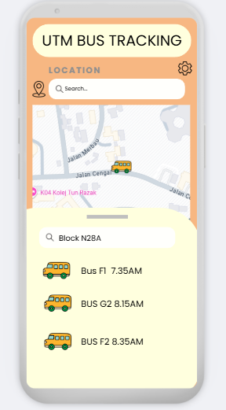

2.5 Test Phase

2.5.1 Testing Method
The prototype was tested through a pilot interview with one university student. The purpose of this test was to evaluate the usability, clarity and usefulness of the Bus Tracking System prototype before conducting larger-scale testing. During the session, the participant interacted with the prototype while checking bus arrival times and searching for bus. Feedback was collected through observation and follow-up interview questions.

2.5.2 Interview Question
- Was the interface easy to understand?
- Did you experience any confusion while using the prototype?
- Do you think notification alerts are necessary?
- Was the real-time bus location accurate and useful?

2.5.3 Feedback Table
Table 4: User Feedback from Pilot Test
Aspect Tested | User Feedback | Action Taken
Interface clarity | Easy to understand | Not change required
Notifications | Needed | Added push notification feature
Real-time GPS location |  | Retain this feature
  Bus location was accurate

Table 4 summarizes the feedback obtained from the pilot interview. The user reported the interface of our prototype was easy to understand so that no major changes were required for interface clarity. However, the user indicated that notification feature was needed. The Real-time GPS location was praised that the bus was accuracy. As a result, our team proposed adding push notification such as bus arrivals and delays to improve the usefulness of the system and address user needs.

Figure 17: Prototype testing session and feedback collection.
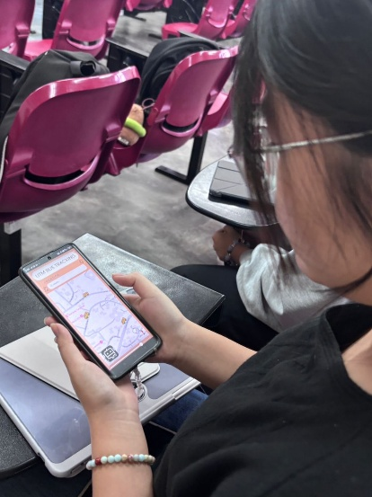

3.0 Problem, Solution and Team Working

3.1 Problem
Students require real-time bus location information to determine whether they should continue waiting. They often waste time, experience frustration, and face potential delays in attending classes or other commitments when they do not receive timely bus updates.

3.2 Solution
The bus tracking system helps users with real-time bus location tracking, enabling accurate arrival estimates and reducing waiting time. It provides notifications for arrivals and delays, supports schedule planning, and includes safety features like night-time SOS and location sharing. An AI chat box is also available for quick access to bus information.

3.3 Team Collaboration
A team consists of four members, so we were divided into Introduction and Assessment Points, Empathy and Define, Ideate and Prototype as well as Test and Evidence. Regular meetings were conducted to discuss the system's development and ensure continued progress. When challenges were encountered, our team discussed them collaboratively to identify the problem and develop appropriate solutions to resolve it.

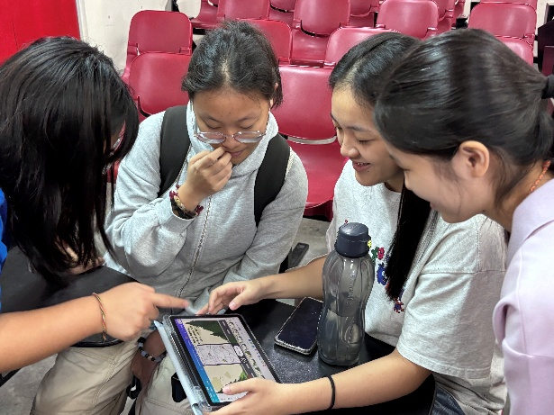
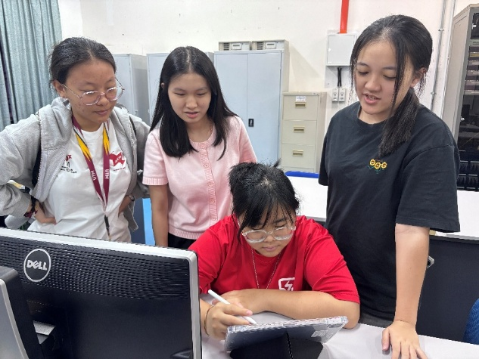
Figure 18 and 19: Photos of group discussion

4.0 Design Thinking Assessment Points
4.1 Check List
Table 5: Check List
Phase | Assessment Criteria (Did we complete these?) | Status (/)
Empathy | Collected user pain points via a Google Form survey. | /
Empathy | Recorded key pain points (eg: long waiting times, lack of info) | /
Define | Created a “Composite Character” (Personal) based on interview data. | /
Define | Formulated a clear Problem Statement (eg: How might we...) | /
Ideate | Generated at least 10-15 wild ideas during brainstorming | /
Ideate | Selected the most feasible solution (Bus Tracking App) | /
Prototype | Created low-fidelity sketches or digital mockups of the app. | /
Prototype | Included key features like “Real-time Map” and “ETA Notifications” | /
Test | Gathered feedback from potential users using the prototype. | /
Test | Documented "Likes" and "Improvements" in the Feedback Grid. | /
Figure 20-22: Evidence of assessment criteria
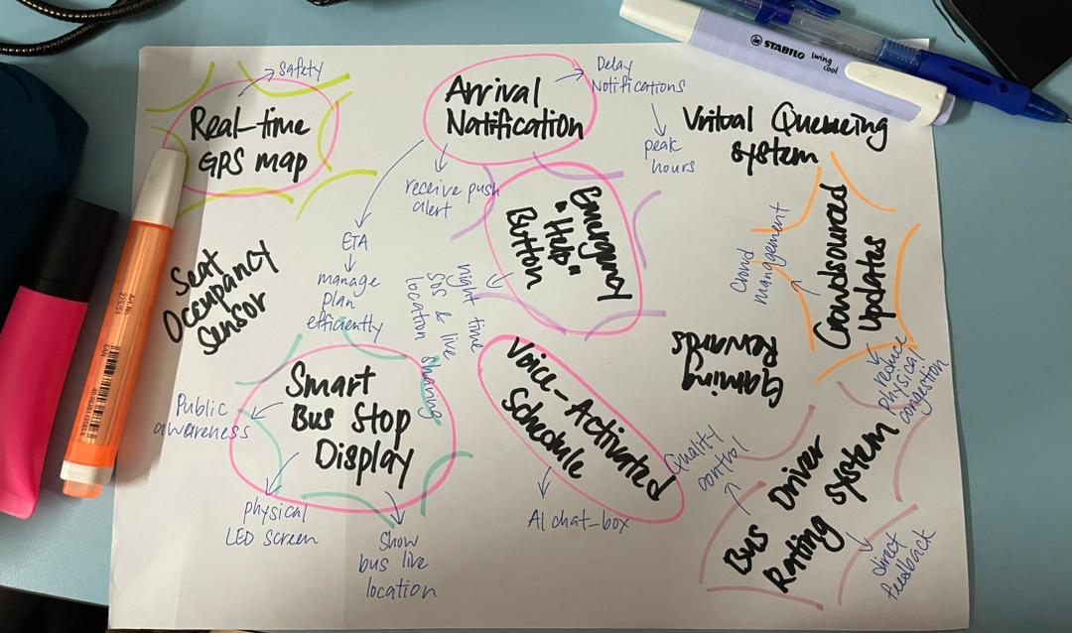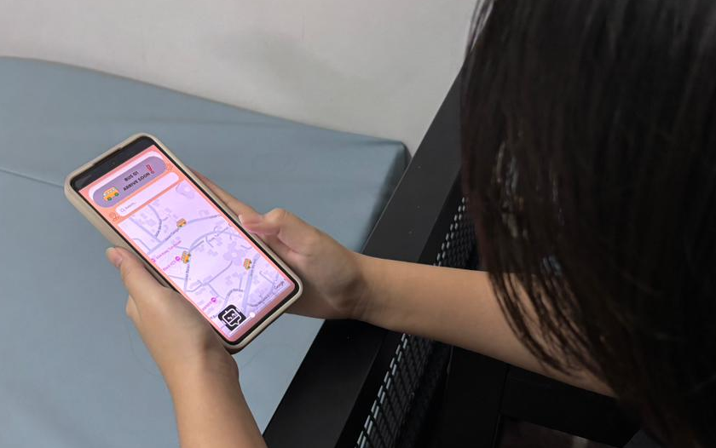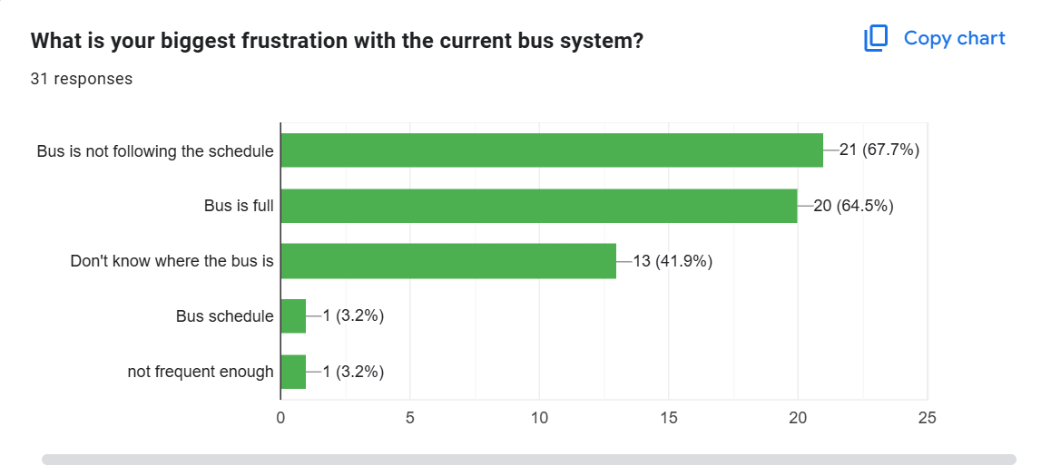
5.0 Reflection

Koo Yu Min
- Goal: To gain broader exposure, engage with various fields and enhance practical knowledge through industrial visits in preparation for future careers.
- Design thinking enables me to analyze the problem, develop solutions to problems encountered in daily life, and understand the importance of teamwork and communication in project development.
- I plan to deepen my understanding and learn additional programming languages to keep pace with the continuous advancement of technology, while enhancing my knowledge and experience through greater involvement in project work.

Lau Yu Xuan
- My goal is to become a member of an app development team where I can contribute to creating mobile applications that are helping people to solve problems in their life and can be widely used.
- I am working on Ideate and Prototype parts sin this project was crucial. I learned that a good app starts by combining everyone's ideas, and drawing the draft first is the better way before developing the apps.
- I plan to practice using the feature prioritization method in my future projects, to make better decisions that are focused on our users. I also plan to learn the basics of the development framework to understand and make a better fundamental for an app.

Chloe Khoo
- My goal is to become a multimedia designer who can develop interactive functional applications with high quality visual aesthetics, but the most important thing is developing an application that can really help everyone in daily life or even emergency.
- Design thinking taught me that good graphics is not enough in developing a software system, but solving user frustrations is the main point. We need to ensure every visual element in our designs truly serves a functional purpose.
- I plan to improve my communication skills and master my technical experience such as framework and coding as a great understanding and communication in a team will lead to success.

Chan Qing Jia
- Goal: Connect the gap between technical functionality and creative storytelling, ensuring that digital solutions are both impactful and easy for users to navigate.
- I'm working on the Introduction and Assessment Evidence for this project. I learned that a project's success depends on each stage because we have to address the real problems that users face.
- I am also working on video editing for this project. To make sure my creative work satisfies the requirements, I also apply formal assessment rubrics to my video.

